SQL ASSIGNMENT – 5

1) Write a query that will give you all orders for more than Rs. 1000.

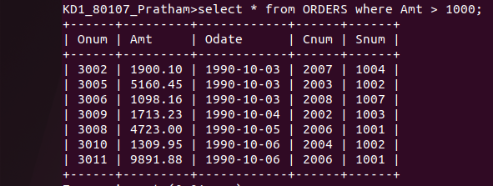

2)Write a query that will give you the names and cities of all salespeople in London with a commission above 0.10.

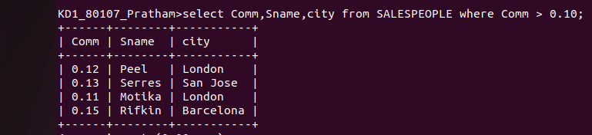

3) Write a query on the Customers table whose output will exclude all customers with a rating <= 100, unless they are located in Rome.

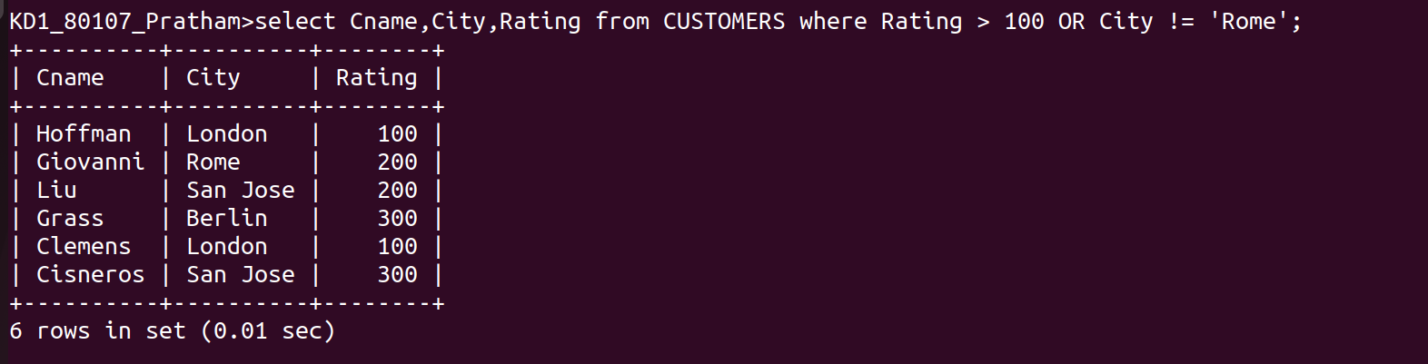

4) What will be the output from the following query:

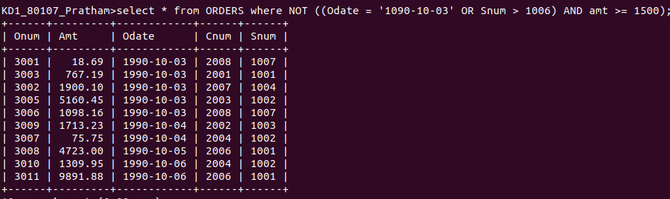

5)What will be the output from the following:

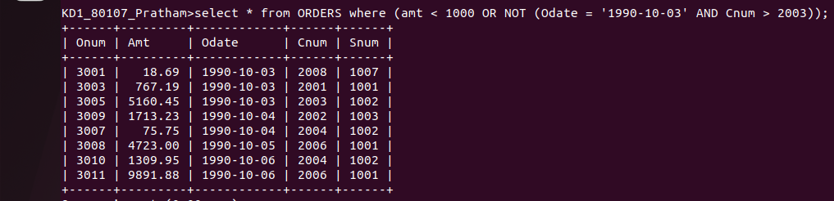

6) what is a simpler way to write this query?



